Project #7 Amazon Workflow Messages

Group 9  
Eric Lin, Kenneth Ven, Sheung Chow, Temesgen Baye

**(NOTE: We have colored non-message arrows blue, all the arrows that go into the user and from the user are non-messages)**

Use Cases: #1 case of ordering and fulfillment.

Customer orders three books, all three books are fulfilled by the SEA Fulfillment Center and shipped to the customer. Customer receives an email when the order is placed, when the order is being processed ( picked ) in the FC, and when the order is shipped ( including shipping information) Customer asks Ordering what the status is of the shipment.

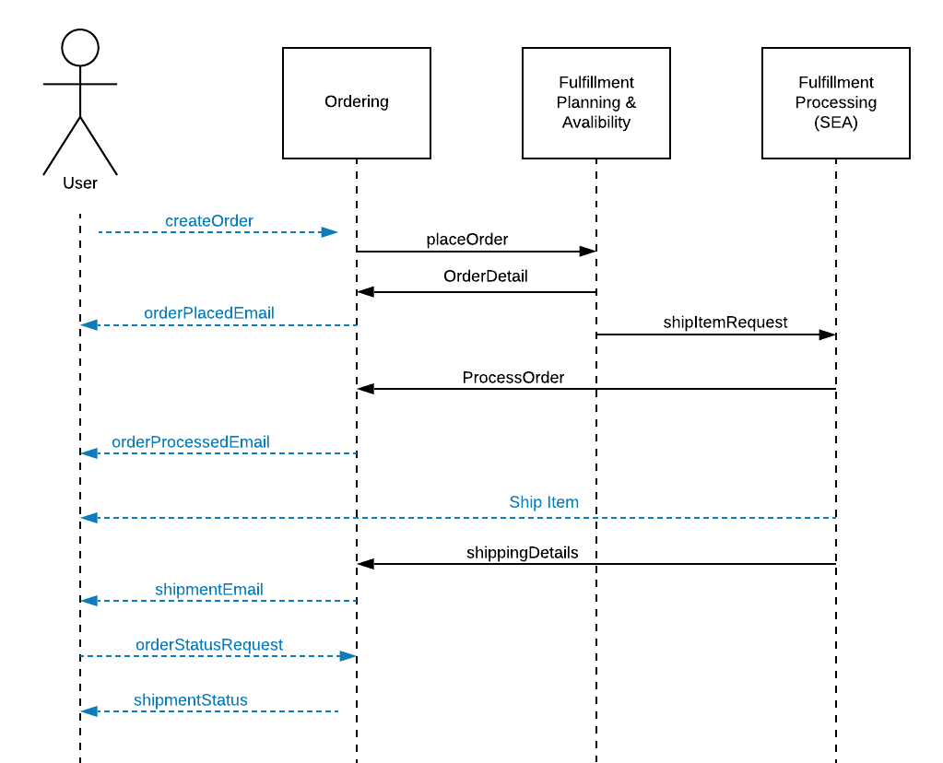

#2 Split Shipment ordering and Fulfillment.

Customer orders three books, Order is split. Two books ship from PHL, one from SEA. Rest of use case as in Happy Case above.

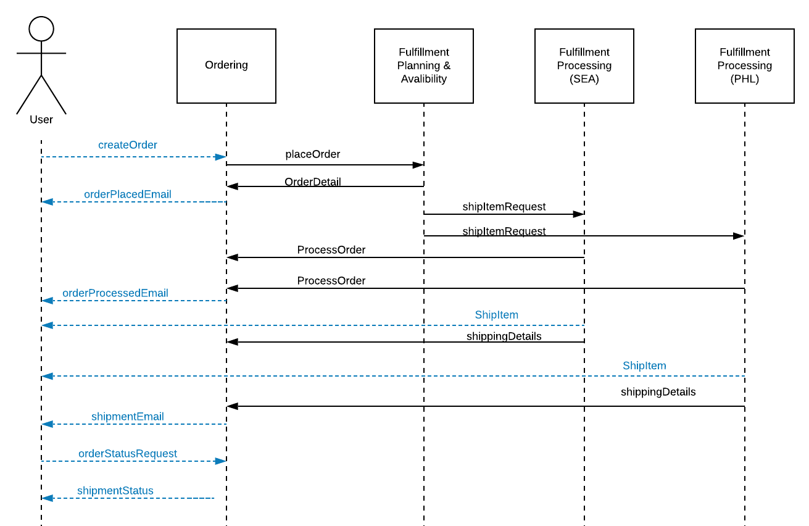

#3 Customer cancels order Success

Customer orders one book. Before the order is planned, the customer cancels the order. Customer receives notification that the order has been canceled via email.

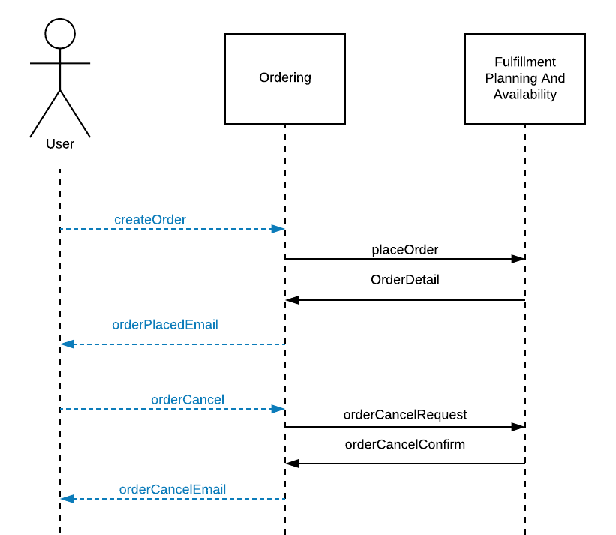

#4 Customer Cancels Order. Success

Customer orders one book. After the order is planned, but before the FC starts processing(picking) the order, the customer cancels the order. Customer receives notification that the order has been canceled via email.

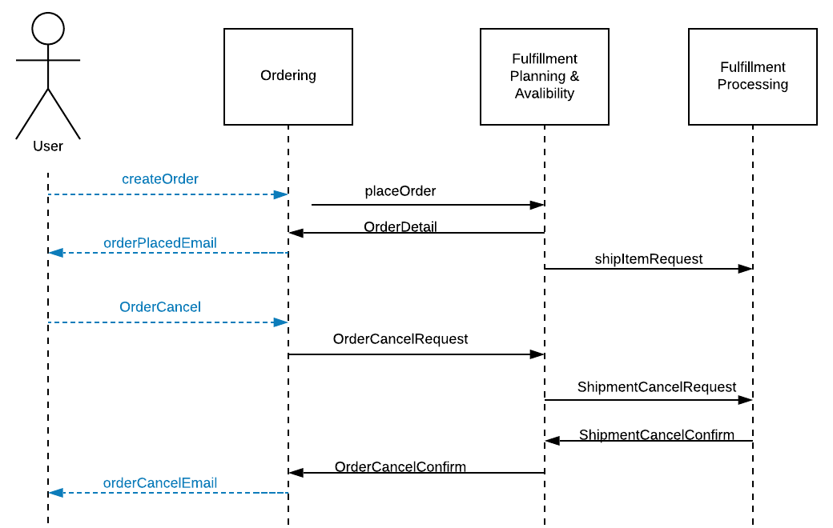

#5 Customer Cancels Order. Failure

Customer orders one book. Order is planned and sent to the FC. FC starts shipping the book. Customer attempts to cancel but it is too late. Customer receives an email that the cancelation cannot happen.

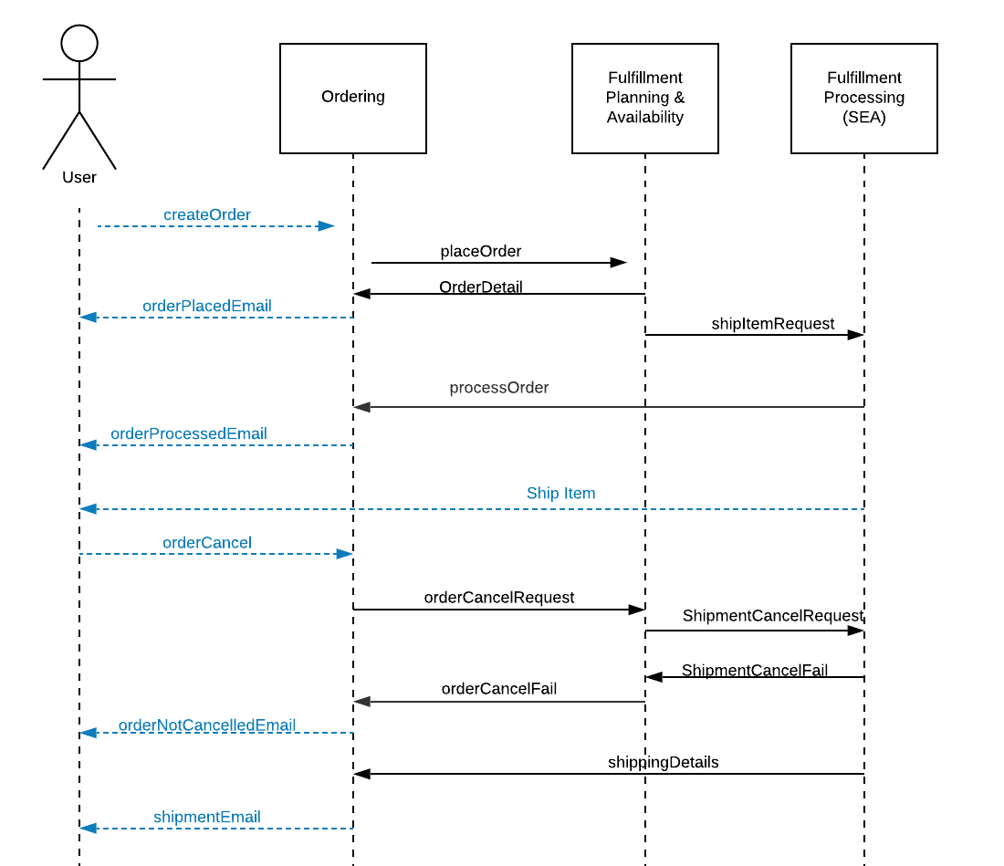

#6 FC can’t ship.

Customer orders one item. Order is sent to PHL. When the item is being picked, we discover that the item is damaged. PHL signals Fulfillment Planning that the book is out of stock. Availability replans the order and sends it to SEA. Customer goes to the website to see what's up with the order and sees the updated shipment informainto.

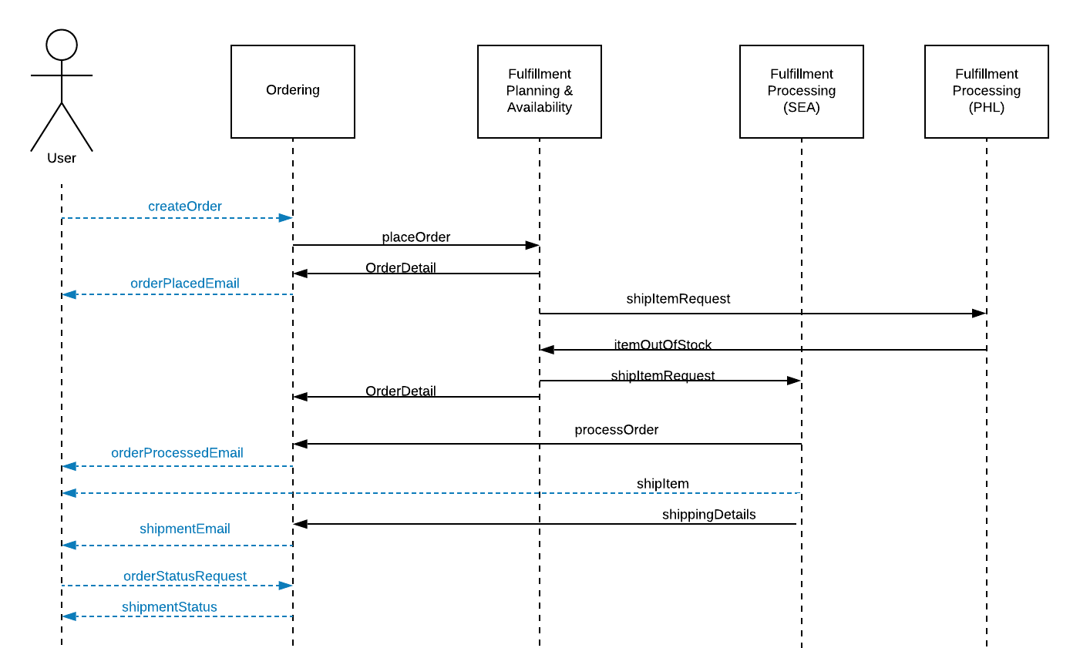

**MESSAGES**

* **placeOrder: Ordering service sends all the details of the order to Fulfillment Planning and Availability service.**  
  {

OrderID: <String>,

CustomerID: <String>,

Items: [{ASIN: <String>,QuantityNeeded: <integer>}, ...],

Address:<String>,

Name:<String>,

RequestedShipDate:<Date>

}

* **orderDetail: Fulfillment Planning and Availability service sends the plan of the order to Ordering service. Ordering service updates the status of the order to Order Placed.**{  
   OrderID:<String>,

ExpectedShipDate:<Date>,  
 Items: [{ASIN: <String>,Quantity: <integer>, expectedArrialTime : <string>},...]  
}

* **shipItemRequest: Fulfillment Planning and Availability service sends a message to let the FC process and ship the order.**{  
   ShipmentID: <String>,

OrderID: <String>,

ExpectedShipdate:<Date>,

Items: [{ASIN: <string>, QuantityNeeded: <integer>}, ...],

Address: <String>,

Name: <String>,

CustomerID: <String>

}

* **processOrder: FC sends a message to the Ordering service to inform that the item(s) of the order has been picked. Ordering will update the status of the order to Processed once all of the items in the order have been picked.**

{

OrderID: <String>,

Items: [{ASIN: <string>, Quantity: <integer>}, ...]

}

* **itemOutOfStock: FC sends the ASIN of the item(s) out of stock to the Fulfillment Planning and Availability to signify an error with the current order.**{

OrderID: <String>,

Items: [{ASIN: <string>,quantityNeeded: <integer>}, ...]

}

* **shippingDetails:** **FC messages Ordering when a shipment is shipped. Ordering will update the status of the order to Shipped state once all of the items in the order have been shipped.**  
  {

OrderID: <String>,

ShipmentID:<String>,

Address:<String>,

ShipDate: <Date>,

Items: [{ASIN: <string>, Quantity: <integer>}, ...]

}

* **orderCancelRequest: Ordering messages Fulfillment Planning and Availability to request order cancellation.**{

OrderID:<String>

}

* **orderCancelFail: Fulfilment Planning and Availability messages Ordering that the order can’t be cancelled. Ordering doesn’t update the status of the order to Cancelled because it has already been shipped.**{

OrderID:<String>

}

* **orderCancelConfirm: Fulfilment Planning and Availability messages Ordering that the order has been cancelled. Ordering updates the status of the order to Cancelled.**{

OrderID:<String>

}

* **shipmentCancelRequest: Fulfillment Planning and Availability messages FC to request shipment cancellation of an order.**{  
   OrderID:<String>  
   ShipmentID: <String>

}

* **shipmentCancelFail: FC messages Fulfillment Planning and Availability that the shipment can’t be cancelled because it has already been shipped. Shipment status of the order will stay Shipping or Shipped.**{  
   OrderID:<String>  
   ShipmentID: <String>

}

* **shipmentCancelConfirm: FC messages Fulfillment Planning and Availability that the shipment has been cancelled. Shipment status of the order will be updated to Cancelled.**{  
   OrderID:<String>  
   ShipmentID: <String>

}